DESIGN & IMPLEMENTATION OF COURSE REGISTRATION

AND RESULT PROCESSING SYSTEM FOR POLYTECNICS IN NIGERIA

(A Case Study of Enugu State Polytechnic, Iwollo.)

BY

Chukwuma Joshua Mgbeosorochukwu

(Espoly/CS/ND/2018/2019/0024)

A PROJECT REPORT SUBMITTED IN PARTIAL FULFILMENT OF THE REQUIREMENTS FOR THE AWARD OF NATIONAL DIPLOMA IN THE DEPARTMENT OF COMPUTER SCIENCE, Enugu State Polytechnic, Iwollo.

March, 2021

CERTIFICATION

This is to certify that this project was carried out by Chukwuma Joshua Mgbeosorochukwu under the supervision of Dr. Mrs. Ezeme Chizoba in the Department of computer science: Enugu State Polytechnic, Iwollo

Approval

This project work has been read and approved by the department of computer computer, enugu state polytechnic iwollo. I therefore, certify that the project work was carried out by chukwuma Joshua mgbeosorochukwu with registration number ESPOLY/CS/ND/2018/2019/0024 in department of computer science, enugu state polytechnic iwollo.

------------------------ ------------

Dr. Mrs. Ezem chizoba Date

Project supervisor

------------------------- -----------

HOD Computer Science Date

Department

-------------------- ----------------

External Supervisor Date

DEDICATION

This project is dedicated to my family for the support and guidance they gave me and the sacrifice they had to make for me to realize my dream and reach this far, especially my dear sister Mrs. Florence Ada Onu, who stood by me in all situations even at the times of financial needs.

ACKNOWLEDGEMENT

First of all I would like to thank God the Almighty for his grace, strength and keeping me throughout the period of my study, to have enabled me to do research and write this work in sound mind and good healthy.

Secondly special thanks goes to my Project Supervisor Dr. Mrs. Ezem Chizoba for her ideas, guidance and support with full of wide experience and endless dedication to see that I finish my project.

Thirdly I thank my sister Mrs. Florence Ada Onu for her endless love, care, prayers and encouragement with full moral and financial support.

Finally, I would like to thank those who have directly or indirectly helped and co-operated in accomplishing this report.

ABSTRACT

Course Registration System is a system that enables students to gather information about particular courses and easily register themselves in particular recourse .A Result Processing System controls the processing of student's results and produces as output examinations cores for the courses offered by the student. This System s together enables the management of an institution to easily see the records of the students their courses and result for each course. This study was carried out to verify all the manual process involved in generating Students Courses and Examination Result and to seek away of automating the system for effective operations. Since there is continuous moves towards technological advances that enhanced productivity of labor and free human beings of task more economically by machines .Computer and it s appreciations have become vital tool sin economic, industrial land social development of advanced countries of the world. This system is designed to efficiently handle processes like inputting scores, Inputting Courses, Storing Courses, storing results, classifying the grade point s automatically calculated, and interpreting data of students overall result. The usual manual process now reached a level where it is difficult for the available manpower to cope with the magnitude of examination work, in the given time span, The balance between the manpower availability and the magnitude of the examination work result in the delay in the release of results. The most effective measure, which can improve the efficiency of the examination system, the reform is the introduction of computerization especially with the use of Examination Result Processing Software in various activities related to the conduct of result reduces the time span required for the release o f results by 60 percent and reduces the process by almost 50 percent. A study in to the manual process reveals the inefficiencies and the rigorous nature of course registration and result processing; therefore the existing manual process was analyzed and converted into an automated system*.* The manual activities was modeled with an object-oriented methodology and the system was implemented with JavaScript, a scripting language, NodeJS aback-end JavaScript runtime environment and MongoDB database management t systems. It provides s a robust database that generates various reports that is relevant to the department. There suit of this research work is a system that automates the course registration and examination result processing for the, which can be used in any department of most universities and polytechnics in Nigeria.

Table of Contents

Title …………………………………………………………………………..i

Certification………………………………………………………………ii

Approval…………………………………………………………………….iii

Dedication.................................................................................iv

Acknowledgement…………………………………………………………v

Abstract……………………………………………………………………vi

Table of Contents……………………………………………vii

List of Tables……………………………………………………….viii

List of Figures……………………………………………………………vvi

CHAPTER ONE

INTRODUCTION

1.1 Background of the Study

1.2 Statement of Problem

1.3 Significance of the Study

1.4 Aim and Objectives of Study

1.5 Scope of the Study

1.6 Limitation to the Study

1.7 Definition of the Terms

CHAPTER TWO

LITERATURE REVIEW

2.1 Introduction 5

2.2 Theoretical Background 8

2.2.1 Technology Used 9

2.2.2 Information Technology 10

2.2.3 Course Registration Result Processing and examination 11

CHAPTER THREE

System analysis and methodology 17

3.1 Introduction

3.2 Data Gathering

3.3 Research Methodology

3.4. System Analysis

3.4.1 Analysis of the Existing System

3.4.2 Analysis of the Proposed System

3.5 Justification of the Proposed System

23

CHAPTER FOUR

Design system

4.1 System Specification and Design

4.1.1 Input Specification and Design

4.1.2 Output Design Specification

4.1.3 Security Design Specification

4.4.4 Database Design Specification

4.2 System Development Tools and Justification

4.3. System Requirements

4.3.1 Hardware Requirements

4.4 Implementation of the Proposed System

CHAPTER FIVE

Summary , CONCLUSION AND RECOMMENDATIONS

5.1 Summary

5.2 Conclusion

5.3 Recommendations

References

Appendix

LIST OF TABLES

Table 3.1 Calculation of GPA

Table 3.2

List of the Figures

Figure 4.2 Shows the Homepage with Menu for the User’s Login.

Figure 4.3Shows the Admin login Page where he can either Add a Course, Add Staff, Upload Results, view Broadsheet and Prints Reports etc.

Figure 4.4 Shows the Form the Add-Course Form.

Figure 4.5 Shows the Result Uploaded Interface.

Figure 4.6 shows the form for student course registration.

CHAPTER ONE

INTRODUCTION

**1.1 Background of the Study**

The effort expended in the process of registration of students and computation of their examination results is much. Quite worrisome is the fact that these processes are carried out every academic session, putting the operators in a continuous and ever demanding cycle. The computation of examination results and registration of students is obviously an object-centered activity, the student being the dominant object in this case. Hence, the need to evolve a computerized process that will effectively and efficiently capture all the important data associated with the registration and examination result processing within the tertiary institutions and the interactions among the objects.

Students’ Examination Result is the summary of each of the semester performance in schools. A students’ Result is also demanded by a student who has finished his/her program. And wishes to transfer to another school or student who wish to get a job. A Transcript is not given directly to a student. It is sent to the school that the student wishes to be transferred, or to the organization or establishment that requires the result.

A students’ Result is prepared or formed by the scores entered on the designed score sheet by the individual course lecturers on semester examinations. This genuine and noble desire necessitated the design and development of the Undergraduate Registration and Examination Processing System software.

There were three fundamentally distinct education systems in Nigeria in 1990: the indigenous system, Quranic schools, and formal European-style education institutions. In the rural areas where the majority lived, children learned the skills of farming and other work, as well as the duties of adulthood, from participation in the community. This process was often supplemented by age-based schools in which groups of young boys were instructed in community responsibilities by mature men. By the 1970s, education experts were asking how the system could be integrated into the more formal schooling of the young, but the question remained unresolved by 1990. Western-style education came to Nigeria with the missionaries in the mid-nineteenth century. Although the first mission school was founded in 1843 by Methodists, it was the Anglican Church Missionary Society that pushed forward in the early 1850s to found a chain of missions and schools, followed quickly in the late 1850s by the Roman Catholics. In 1887 in what is now southern Nigeria, an education department was founded that began setting curricula requirements and administered grants to the mission societies. By 1914, when north and south were united into one colony, there were fifty-nine government and ninety-one mission primary schools in the south; all eleven secondary schools, except for King's College in Lagos, were run by the missions.

The education system focused strongly on examinations. In 1916 Frederick Laggard, first governor of the unified colony, set up a school inspectorate. Discipline, buildings, and adequacy of teaching staff were to be inspected, but the most points given to a school's performance went to the numbers and rankings of its examination results. This stress on examinations was still used in 1990 to judge educational results and to obtain qualifications for jobs in government and the private sector.

As more information is made available in a variety of formats and media and in a variety of locations, the need to manage information/data efficiently becomes more and more critical. Both staff and public users want access to stored information and want to access it more efficiently. It is the Polytechnic Policy to improve both the efficiency and effectiveness of course registration and result processing operations and services through the implementation of an integrated automated database System.

**1.2 Statement of the Problem**

The problems identified in the old system are as follows:

* The old system does not have a unified database system.
* There is no structure that compels students to register all outstanding courses before proceeding to the recent ones

Student s test and exam scores may be entered wrongly when manually done.

* It is very cumbersome to manually reconcile all registered courses from different Files sources into their work sheet for the purpose of result computation.

**1.3 Significance of the Study**

The significance of this study is to design and implementation of Student Examination Result Processing System is to achieve the speedy registration process, speed of the results processing, to eliminate error due to manual processing and to provide security measure to check student mischievous act of changing marks on the result sheet. The Software will also provide a well functionality of student experience activity on student portal with various student and lecture’s interactions. The project work will help in a good number of ways to ease the delay in manual examination processing.

**1.4 Aim and Object of the Study**

The aim of this study is to develop student registration, course registration, examination registration, result processing and student transcript in less time, accurately and fast processing.

The objectives of this study are to:

* Provide a reliable solution to result processing that is corruption free.
* To enhance the speed of the results processing.
* Ensure that normal credit load in line with the school is maintained.
* Provide a software that will generate result that is accurate, timely and error free.
* To keep accurate record of students examination Results in the school and prevent lost of result, which are vital to the exams and records.
* To provide a long time database backup.
* To process and transfer student academic transcript.

**1.5 Scope of the Study**

This research work will concentrate on student registration, course registration, academic transcript, examination processing, result processing system in Enugu State Polytechnic, iwollo, Enugu State and can be extended to other Polytechnics.

**1.6 Limitation of the Study**

The limitation to this study includes the lack of needed time frame, lack of needed materials to complete the project.

**1.7 Definition of the Terms**

The following are some terms commonly used in this project.

Direct Data Captured: Data is capture directly without a conversion stage, by means of the input devices such as mouse, keyboard, pen writers, cameras, fax, e.t.c.

These are hardware that helps to send data in form of input to the computer.

On-line Data Entry: Data is entered directly into the computer one transaction at a time (also known as transaction processing) under program control.

Students Examination Result: An official record of student’s work that show the courses they have taken and the marks they have achieved.

CHAPTER TWO

LITERATURE REVIEW

2.1 Introduction

Literature review is the assessment t o f previous work carried out t on the same e or related projects and extract s relevant points to serve as milestone in the project t a t hand. Various works were studied and analyzed. There view and the lessons learnt forthwith, informed the choice of technologies employed for the development of this research output which is contained in the theoretical background.

2.2 Theoretical Background

The theoretical background gives an overview of the technologies used in developing the system “Course Registration and Result Processing System” and the general concept of the research topic as seen by the other researchers. The technology is chosen in other to present a more user friendly system. The site developed comprises of various we b contents written in HTML, JavaScript and MongoDB server used the development of the database of the system.

2.2.1 Technology used

The HTML language comprises of forms, cascading style sheet (CSS) and HTML elements. .The cascading style sheet was used to form at the presentation of the output. I t adjusts the sizes and fonts of the window display area.

The CSS file was used to implement the font sizes, the page body structure and the entire styling of the webpage.

E.g. of a CSS code fragment is.

body,html{height:100%;padding:0;margin:0;}.wrapper{min-height:100%;min-width:950px;overflow:hidden;}

This code gives the margins and height of the webpage. The wrapper shows s the relative position of the web window to the laptop screen. The HTML elements comprise of sequence of element in this form.

<html><head></head><body><p>Welcome</p></body></html>

This code fragment outputs a message on the screen.

The MongoDB Model that creates a result table is given thus:

import {model,Schema}from'mongoose'

constauth_schema=newSchema({

name:{

type:String,

required:true

},

regno:{

type:String,

required:true

},

ca:Number,

exam:Number,

Total:Number,

grade:String,

session:{

type:String,

required:true

},

coursecode:{

type:String,

required:true

},

createdAt:{

default: Date.now(),

type:Date

}

})

Export default model('Auth',auth_schema)

2.2.2 Information Technology

Information technology is the application of a set of computer tools, processes and methodologies t o collect data and present information inform that will sooth the present day business operations. In the beginning of the 21stcentury, it is difficult t to imagine the development of the modern world without extensive use of the information technology that is rapidly transforming the global, knowledge-based economy as well as the entire societies MosesE.Ekpenyong.‘AReal-TimeIKBS for Students Results Computation’, Volume20, Number3 (M), (2008) Page2. Information technology (IT), stands to address how business operation s can be abstracted in to a useful IT knowledge, and how such knowledge can be applied to ongoing operations .The disintegration of record management program in organizations has led to the inefficiency in administration and loss of vital information needed for decision making. Therefore to ensure reliability, efficiency and transparency in the computation of result s and development of ad hoc reports, the design and implementation of a Computer-based Result Information Management System must be integrated into the system Moses E. Ekpenyong. ‘ AReal-TimeIKBS for Students Results Computation’, Volume20, Number3 (M), (2008) Page2.Nearly every section of the educational system requires information processing. With the use of computers for information processing, instant access to the academic admichastiary educational community, information is highly essential for correct student instructive information will be possible admichasater Emmanuel Band Choji D.N. ‘A Software Application for Colleges of Education Students Results Processing’ ,Vol.2,No.11, (2012)Page12-18.According to Emmanuel Band Choji D.N. ‘A Software Application for Colleges of Education Students Results Processing’ ,Vol.2,No.11, (2012)Page12-18, one of the largest investments in many organizations is the creation, maintenance, and retrieval of information. As been estimated that in an organization units ’record and examination data. Student information, if not properly created and stored, will cause many errors in usage and may be lacking in integrity.

**2.2.3 Course Registration and Examination Result Processing**

Course registration is a process in which student s upon resumption and registration proceeds to register for the courses required of them for the semester. This gives availed definition of the area of study and the student’s academic activities. Result processing is a process by which students will be examined on the courses the y registered for and the result will be produced by the examiner. Worldwide, it is known that the imbalance between manpower availability and the magnitude of work to be done in processing examination results, leads to the delay in the declaration of examination results. An effective measure, which can improve the efficiency of the examination result processing, is therefore the introduction of computerization Akinmosin James. Automated Students Result Management System Using Oracle’s Database, Vol.4, No.11, (2014) Page1.It was observed that a number of problem s associated with student academic record management include improper course registration, late release of students ’ results, inaccuracy due to manual and tedious calculation and retrieval difficulties/ in efficiency, According to him, the development of data base concept is the answer to these problems where the amount of redundant data is reduced and the possibility that data contained on a file might be inaccurate because they were never updated Akinmosin James. Automated Students Result Management System Using Oracle’s Database, Vol.4, No. 11, (2014) Page1. A according to Ukem Eyoo. And Ofoegbu Francis. ‘A Software Application for University Students Results Processing’, Vol.35No.1, (2012) Page1,34-39, the increase in students’ population over the years has made the work of administrative officer in charge of processing students’ result a very tire some exercise to deal with. The r is e in the number of students in schools today made it imperative that we continue to seek out the best and most efficient ways to handle schools and school administration. Similarly in Ezenma A. Añulika .Design and Implementation of Result t Processing System for Public Secondary Schools in Nigeria , Vol3, Issue 01. January 2014.Page123, it was observed that the computerization of secondary school result s processing system has the following importance;

* Efficiency:-A computerized system will make the job of result computational more efficient and student t s will obtain their results soon after the marking of the scripts is completed.
* Accuracy: Interactive processing identifies and correct error due to negligence.
* Retrieve ability:- Retrieval of information is a lot more easier.
* Safety and security: information store d in the computer is safe from animals, insects and intruders. Also a password can be used to make program assessable to only authorized persons. Furthermore, in Anigbogu, S.O .Computer Application and Operation First Edition, Awka . (2000). Page18.It was stated that a college portal is personalized software that captures the entire education business process and makes all operation s accessible via the web , thus allowing schools to effectively serve all stakeholders, students, lecturers, administrators and parents.Also in Emmanuel Band Choji D.N. ‘A Software Application for Colleges of Education Students Results Processing’,Vol.2, No.11, (2012)Page12-18, it was stated that Publication of student’ s results in the manual system take s a very long time thus students remain idle for month s waiting for their result. Sometimes the delay in declaration of result cause heavy losses to the students as generally they cannot join further studies or appear in competitive exams or join jobs because of the non‐availability of examination result in time. The process becomes a lot easier and much more accurate when automated, because the computer is capable of accepting and storing raw data, processing it, and storing the results until when needed Ukem E.O and Onoyom-Ita E.O ‘A Software Application for the Processing Of Students Results’, Volume17No.4. (2011)Page1.

**2.3 Review of Related Literature**

The University of Nigeria, Nsukka for instance, has an existing portal system. The portal was developed with a MYSQ L server and script languages. The system has the ability to handle student’s course registration but not result processing. Students update their bio data and register for courses online. The online activities stop at the level of registration as students have to print the registered course form and submit a copy to the academic adviser. The academic adviser checks and end or see the course registration form based on the oral report of previous performance given by the student. Examination is taken and result is published by the examiner. Copies of the result copy are sent to the exam office r of the department who computes the result through manual process. Problems identified with this system are:-

* Result computation is not automated and therefore very cumbersome.
* The system has no means of ascertaining the correctness of course registration report before the academic adviser validates it .i.e. There is no mean so f knowing student s who registered their failed courses and those who do not.
* The system is prone to impersonation and double registration.

Therefore the proposed system guarantees an efficient process. It builds in a mechanism that pools all failed courses and force the student to register courses starting from the failed ones. It has a robust database that generate s all students ’result information reports.

Other attempts have been made to improve the result management information system. MongoDB Server, a Non-Relational Database Management System, was used to create the database tables and data. Nodejs was used to communicate e with and manipulate the database. Thus the following is how the system works.

The computers of t ware application has four sessions, namely: the“ Super Administrator” session, the “Staff /Administrator” session, the“ Staff” session and students’ session .The Head of Department (HOD) has the authentication/permission of the Super Administrator. He performs the following functions:

* Register student s in individual units of the Department
* Register staff in the Department
* Enlist courses offered in the Department
* Assign courses to registered staff in the Department
* Assign examination officers to individual units

And also perform the role of a staff and also of an examination officer of a unit.

The second personnel in the department is the staff/ administrator. He/she is a registered staff of the department and thus has valid username and a password. He performs the following functions:

* Enter students’ scores and view students ’ grades in the course s he coordinate
* Process students’ results in his unit, which includes calculating the GPA and CGPA
* View all the students’ results in his unit.

A Course Coordinator has the authentication of a Staff. Hence, he is registered by the Super Administrator and thus have availed username and password. He should be able to perform the following functions:

* Enter students’ scores for the courses he coordinates
* View the grades he entered.

A Student he is registered by the Super Administrator and thus have a valid username and password .He should be able to perform the following functions:

* Register his/he course per semester
* View the courses he entered and result for previous semesters.

The system is designed and implemented such that the following are carried out during its use:

* User validation: To be able to use the software, staff are to be registered by the HOD with a default username and password on the first login to the software.
* Students Registration: Students in the Department are to be registered on the system.
* Course Registration: courses offered from first year through final year are registered.
* Course Assignment: After course registration, staffs are assigned courses that they will teach.
* Usage: At the end of the period (semester or session) staff will login to the software and enter students’ marks for any course the y are assigned. Staff can also view result already submitted, if they want, or change their password when desired, Academic adviser is the one that has the authentication of a staff/administrator. He can process students’ results (i.e. calculate GPAs and CGPAs) with the respective units for any academic session they choose. An academic adviser can also view any student’s GPA and CGP A in his unit .Finally, HOD can view all staff, student and course registration, as well as be able to view any student ’s result irrespective of the students unit.

The out puts from the system are various. They include e a listing of registered staff, registered courses and registered students. Result for a single student in all the courses for on e academic session can be shown. Processed results can be viewed for one student at a time, or for all the students in a Unit.

However, the problems identified with this system are thus:

The system does not provide a means of validating student’s course registration. The Super Administrator who registers students does not check the student’s past academic record before he registers him/her. The new system designed, runs through the student’s data base record and extract courses he/she failed or does not have result, uploads into the form before the student can go ahead and register the remaining courses if the remaining credit units permits.

Each lecturer handling a course enters the student’s scores directly into the database. This allows the various lecturers to have access to the result file that is not under his unit. There is tendency for these grades to be altered. Therefore the new system developed drops this feature and allows only one access to the result file. After the HOD has approved the result, a soft-copy of it is sent to the administrator who upload s it through an excel file. He alone calculates GPA and grants access to students to view their result.

The old system allows an academic adviser to enter scores and view grade s for the courses he coordinates .In the new system, entering and viewing of student’s grades should be restricted to the lecturer that handles the courses alone so that data in the result sheet can be reliable. Never the less, the current system as designed, borrow s some feature so f the system reported in Ukem EyoO. And Ofoegbu Francis. ‘A Software Application for University Students Results Processing’, Vol. 3 5 No.1, (2012) Page1, 34-39. It imitates the system’s ability to present a particular student’s result file in on e sheet together with his GPA for the semester. That means it would generate student’s transcript for a semester. The impact of these changes in the new system is the birth or production of a system that is more transparent and reliable. Access to the system is to be restricted to only one user so that the integrity of the database will be maintained .When students are able to view their transcript or a semester, it will facilitate improvement in their academic program. In the result system above, the course coordinator represent the lecturer that teaches and mark examination papers. The staff/ administrator represent the academic advisers that handles and coordinates a specified number of students. The super administrator s the head of the department.

A portal for processing of results in colleges of Education was reported in [6]. The software application has three main sections namely: the login window, the main menu and sub menu. The login window request s availed username and password from the Administrator to b en able to gain access into the software. The Administrator is any staff that is authorized by the management of the school to be in charge of exam sand record unit, hence he has a valid username and password created by him to be able to login to the software. The Administrator performs the following function:

* Create user account for Lecturers (academic staffs), Departmental Exam s
* Officers and Head of Departments.

The Head of Departments must have a valid username and password to perform the following function:

* Register students in his Department
* Register staff in the Department
* Register courses offered in the Department
* Assign courses to registered staff in the Department

Assign examination officers to Different levels (i.e.NCE1, 2or3).

The Departmental Exams Officer of each level has the authorization of the Administrator. He/ she must have a valid user name and a password .He performs the following functions:

* Enter student’s scores and view students’ grades as it is in the raw score sheet.
* Process student’ s results in the department, which includes calculating the GPA and CGPA
* View all the students’ result s in management approved format (Agreed marked sheet)
* The Lecturer (Academic staff) is authorized by the Departmental Exams officer. Hence, he is registered by the Administrator, has a valid user name and password.

He performs the following functions:

* Enter students ’scores or course she/ she thought.
* View the grades he entered.

The computation of student’s result is guided by the Five-Point Grading system used by all college so f education in Nigeria. The five-point grading system is incorporated into the software for the result computation. However, the system though tested and trusted does not indicate if a student’s course registration is correct or not. The result sheet does not show a particular student’s result together with his/her GPA. The new system is built to enlist student’s result together with the GPA for each semester. Again, the system allows the academic adviser to enter grades for student s in his unit. This access is revoked in the proposed system as only the lecturer is required to enter student’s grades. The overall impact of this in the new system proposed is that the integrity f data will be maintained. The existing student’s information system in Car it as University as reported in Mar candy. Design and implementation of Course Registration and Result Processing System. Caritas University, Amorji Nike Enugu. (2012). Page13, 50-60 has the following functionalities:-

* View Student: this function creates different view so fall the student data.

When you click on the view student link, a page displays where you will be asked to add a student, search for a student or upload list of students.

* ACCESS STUDENT’S RESULT: This link enables one to access and computes student’s result. The process of accessing student’s result entails that the course and the semester in which the course was taken already exist in the database as entered by the student before result can be accessed. The following functions are obtainable: Access student’s result; Find result and calculate result.
* FACULTY/DEPARTMENT/COURSES: This link enable access to faculties, department s under the faculties and courses offered by the departments .Here you can check and explore the departments that exist in a faculty and the courses offered by each department. The feature “Add Student” would likely cratered uncanny and decrease the reliability of the student data. Anybody can come from anywhere and ad d his/her name in the students ‘list. The proposed system modifies this feature by the upload student function. Student’ list comes from the admission list ,if any student is omitted from the list or has late registration, the name will be included in the department and sent to the administrator in an excel file. Then administrator then uploads the list in to the MYSQL database.

Secondly, the function “access result” finds a single result for each student at a particular time. It runs through the semester courses and bring the result of a particular course while the new system checks the student’s level, semester and session. It then enlists all the results for the curse s offered in that semester and calculates the GPA for that semester. A Portal system enveloped for Covenant University Kept Dan. ‘Registration and result processing system in Covenant University’ (2002) page9-12, deployed an ICT solutions that attends to the integral university’s academics administrative problems.

* Automating the core university services
* Automating data management services

They developed and managed packages that is responsive to the changing needs of the users by

* Automating Technical Support Services
* Website design and development
* Design and Management of the University Portal
* Coordination of data entry into the various database systems including students’ record/portal

Collecting and collating data and producing reports needed by external bodies and agencies like: WAEC, NECO, NYSC, NUC, JAMB and other professional bodies. The solutions provided by the Covenant university sedBlade database server to provide data solutions to the school. The data information provided is as follows

* University Basic Data:- Colleges; Branches; Departments; Programmers’ and Buildings.
* Student’s Data:-Student’s Records keeps all the information that directly relates to the students. Such information includes: student’s application, entry and personal information.
* Courses:-Course Listing (Code Description, Unit and Classification).
* Staff:-Staff records showing personnel, departments, seminar s and conferences attended.

Application Modules:-The modules of the application provide interfaces for the entry and update of student’s personal information, course registration information, course allocation information and student’s result information. The reports provided by the covenant university portal shows that it satisfied80% of the expected output of data processing. A study carried out in OderaTom Akal and Oloko Margaret A .‘Effect of Online Registration on Exam Performance in Kenya Certificate of Secondary Education Enrolment’, Vol.3No.7 (2013),page 118, determined the extent to which online registration has eliminated course registration and result processing problems. It was established that online registration has not only erased some problems inherent in the manual system but has enabled efficient process. A study revealed that it has greatly reduced multiple registrations, impersonation and registration flaws. These claims were weighed on a Likert scale and the result shows that the respondents “agreed” witha90%confidence. The results show that online registration is quicker than manual system, it enables a student know ifs/he has been registered for the examination, it reduces paper work and it is more reliable than manual, However, the results found out that the online portal has some draw-backs. Users usually experience Pin rejection, login difficulty, inability of the portal to identify candidates, inability to attach picture, failure to save page, registration modification difficulty, irregularities n the course contents. These problems are addressed in this research work.

Course Registration and Result System carried out in Cardiff State University. ‘Examination Result Processing Manual’. External ExaminerHandbook,http://www.cardiff.ac.uk/regis/ifs/exex/index.html.(2012).Page16-25

.

The system operates as follows.

* Students

Students are the main target of the result process. They can log onto the site to register their courses or check for registration errors. They can register their courses online

* Rectify any Course Registration Errors
* View Results Online.
* Registration Staff

A record officer accesses the list and approves or disapproves of student’s registration for a course.

His function is to

Add or Remove Student’s Registrations

Students that are not captured on the list but are taking the module will the need to approach the registration staff for rectification. Students that are on the list but not taking the module can be flagged by the module coordinator when the list gets to him and this information is passed to registrations staff.

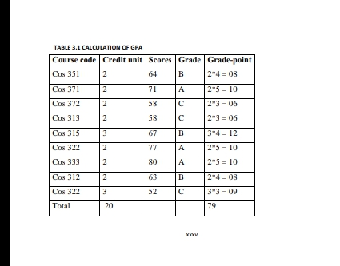When a class assignment has been issued, academic staff will validate the class list provided to them in registration list. Where errors or omissions have been discovered registrations will need to be amended accordingly. If a student is not registered for a module that he/she is taking, the student will need to be registered, however, if this student was not on an exception report, the I r registration record may need to be discussed them ensuring that they are registered on all correct modules. If a lecturer discovers that there are students registered on the module but are not taking this module, these students will need to be contacted to rectify their record.

This review of the existing result processing system in other universities or polytechnic gave birth to the new system. The old system was modified, dropped some functions and incorporated some functions into the new system. The new system is a system that would solve the problem of improper course registration, impersonation into the exam hall, late release of students’ results, inaccuracy due to manual and tedious calculation and retrieval difficulties/ inefficiency.

CHAPTER THREE

System analysis and methodolo

3.1 Introduction

System Analysis and Design is the process of examining the business of an

Organization with the intention of improving it through better procedures and methods. Analysis of a system specifically involve looking at a system, determining how well it functions, specifying changes that needs to be made and the quality or impact of the output that will be achieved. Designing a system

Involve integrating various procedures into the subsystems components and articulating them together into the main system in other to achieve the expected

goal. Analysis and design of a new system requires a modeling methodology. The modeling methodology creates a representation of the real-world entities of the system the object-oriented model was used for the design of the course registration and result process system because it simplifies the software design process by presenting each module as an object and provides an efficient way of

Communicating with these objects. Object-oriented model represents the real-world entities as systems objects. The objects are described by their attributes, behaviors and relationships.

3.2 Data Gathering

* Primary source
* Secondary source

A Thorough investigation of the current system was made in order to obtain detailed fact about the application area to be re-designed. Investigational so covered looking at the functional requirement of the present system and finding out where the requirements and objective of the present system are being achieved. In the investigation proper, several method s of data collection were employed which includes interviewing of office representatives, evaluation/inspection of form s and direct observation. These methods were adopted to ensure the validity of data collected and relevance of the result after processing the data.

3.2.1Interviewing

In view to investigation, office representatives were interviewed such as the lecturers, HOD and faculty officers. This method yields the most profitable result as it is obtained by physical contacts, hence a firs t hand knowledge of the various processes involved is obtained by speaking to .The essential element of the interview is obtained directly and in a short time than when other methods are employed since the interviewer is with the interviewed. This immediate feedback gives the opportunity to ask ambiguous s questions and hence, obtain detailed responses.

3.2.2 Observation

The method of data collection enable s the researchers to witnesses first and operation of the old system or manual system. Direct observation is the surest method of learning as scientist and this method was richly employed. During the observation, we had of:

* The volume of work carried out
* The course registration processing
* The school filling system

3.3 The Research Methodology

For us to achieve all these stated above, we made use of the internationally accepted software engineering model, which are Structured System Analysis and Design Methodology (SSADM). Structured System Analysis and Design Methodology (SSADM) is a systems approach to the analysis and design of information systems. SSADM method involves the application of a sequence of analysis, documentation and design tasks concerned with analysis of the current system, logical data design, logical process design etc. the steps involved are;

**3.4 System Analysis**

System analysis can be defined as the process of examining or studying the structure of an Existing system with a goal of improving it. It is concerned with functional and non-Functional requirements of a system. It is also the process of breaking down a problem into smaller units for a close study individual parts. The purpose of such process to discover a feasible solution to the identified problems in the system and have a clear understanding of it.

**3.4.1 Analysis of the Existing System**

The existing result processing system of Computer Science dept is a manual

Process. Students who have duly paid their school fees are thus eligible for course registration. As they open the school registration portal, they enter their personal detail and fill in the courses as prescribed by the department. This registration form is printed and sent to the department and faculty officials for validation. Three Personnel are responsible for this validation.

I. The Academic Adviser

ii. The HOD

iii. The Faculty Officer

The essence of this validation is to ensure that the student is eligible for that

Registration and that the required courses have been registered. After validation, Photocopy of form is submitted to each of the lecturer in charge of the registered courses. The forms collected by the lecturers from various students are used to compile the class list. Exams are taken and lecturers compile result. Each lecturer submits his/her result to the HOD for approval. After that, a copy is sent to the result processing unit. The various results from the different lecturers are collated and kept together. The exam officer enters the student s grades for each course in the student s work sheet and results are computed.

The courses offered in a degree program are allocated a number of credit units

Which vary from one course to another, because the courses vary in their needs and scope. Hence some courses are allocated greater credit units than others. The measure of performance of a student in any course is given by the grade-points obtained in that course. The grade-points (GP) obtained by a student in any course are determined by multiplying the value of the grade (numeric grade) by the credit units of the course. The total grade-points are obtained by summing up the grade-points of all the courses offered. The Grade-Point Average (GPA) is computed by dividing total grade-points by the sum of credit units of all the courses offered in

that period. Thus;

The GPA is manually computed as illustrated above. The Cumulative Grade-Point

Average (CGPA) for a period is obtained by dividing the cumulative sum of the

total grade-points over the years by the cumulative sum of the credit units over the same period. Thus, Total Grade-Points of the courses offered in the

GPA ----------------------------------------------------------------------

Summation of the credit units of the courses in that year

The GPA is manually computed as illustrated above. The Cumulative Grade-Point

Average (CGPA) for a period is obtained by dividing the cumulative sum of the

total grade-points over the years by the cumulative sum of the credit units over the

same period. Thus,

Cumulative sum of Total Grade-Points of the courses from year one up to the present year

CGPA -----------------------------------------------------------------------------------

Cumulative sum of the credit units of the courses up to the present year.

When the result of student A is to be computed, the exam officer searches through each published result to locate the result of a particular student and fills in the course grade in the corresponding column of the student s work sheet. The same process is repeated until all the results for all courses registered by the student are found and entered. Then the grade is computed.

Table 3.1 is a example of a result computation sheet for a particular student.

Total Grade-Points = 79

Total Credit-Units = 20

Grade Point Average = 79/20;

GPA = 3.95

After the analysis of the current system, the following problems were identified.

Students do not register courses as prescribed by the department. This leads to delay in computing their result as the courses registered will not correspond to that required by the department.

* Manually tracking of results before computing the GPA and CGPA for each
* Student is laborious, especially with increasing number of students, and this prone to error.
* There is no centralized database system that can track registered student

List for a course

* The system does not have any means of showing all semester results for all courses in a single sheet.

3.2Analysis of the Proposed System

The itemized problem of the existing system can be solved or eradicated through the newly proposed system. It is better that records are computerized than dose manually to avoid errors during data transfer of record and result. Those difficulties encountered in the existing system can be reduce using the proposed system. Source program or application software will be developed which will perform the following task.

* Read the master file as input data.
* Process the students result
* Generate report for student score, grade, and grade point for each semester after a specified screen layout and dialog design.
* Append new records to the master file for processing.
* Modifies the existing records e t c.

To a great extent this eliminates duplication, redundancy and provides solution to some other itemized problems. Before user will be allowed access, it must be an authorized user. This is done by keeping the files of all authorized user who will have to enter their valid school information (matric number, level, department and institute) which will determine either they will be allow access or not. This will enhance data and information security.

In this new system, proof of ownership was implemented so that result of someone cannot be inputted for another person. Immediately the school information detail of a particular candidate is inputted into the system it display the corresponding photograph of the owner, to be sure that the result about to be inputted is to the right person.

In the new system student are expected to do their profile registration, course registration and can view their profile and result information. In the new system the administrator are expected to do the course introduction, department introduction, score entry into the system.

Some of the advantages of the proposed system are:-

1. Work Flow :can be done through network i.e. ( if other institute are as well computerized) which enhances maximum accuracy, efficiency and reliability as source data are readily presented with computer, file organization and access mode is done at its best and internal disk are performed adequately

* It enhances great flexibility in processing student result.
* It is specialized, simplified and standardized

b. Control: A major steps are performed internally and automatically without user intervention, it can carry out the operation repeatedly without delays

c. Time: it satisfies time requirements in terms of speed of requirement and access times for processing and executions.

* Adequate storage facilities for both input and output data.
* Duplication, redundancy and insecurity of data are completely eliminated.
* Files retrieval and saving are perform adequately at any point in time

**3.5 Justification of the Proposed System**

An Object-Oriented software enables:

* Increased understanding - Software design process when presented with the Object-oriented analysis makes the understanding of the software easier. Using the course registration and result processing system for example, the system will have objects such as Students, Courses and Staff. The system will support behaviors such as course registration, student s profile update and staff profile update. Further class refinement can be achieved by breaking down the objects into different levels. Example, the course class can be refined as 1st year, 2nd and 3rd year courses. Each year courses can further be broken down into first and second semester courses.
* Code Reusability: the code for a particular function is articulated under one file, this function can be called up as often as possible for reuse. E.g. the header files. The header or title for the software course registration and result processing system is placed in one Html file and it is called up for reuse in all the files such that every web page has the header name or title.
* Ease of maintenance: Problem with one file do not affect the other files.

Diagnosis can easily be traced to the source and corrected.

CHAPTER FOUR

Design system

4.1System Disgn And Implemention

The requirements of the Design and Implementation of Multimedia System demands that a capable programming language can be used for its implementation. Hence Nodejs, Javascript was chosen.

Nodejs: Node.js is a cross-platform environment and library for running JavaScript applications which is used to create networking and server-side applications.

Node.js uses an event-driven, non-blocking I/O model that makes it lightweight and efficient, perfect for data-intensive real-time applications that run across distributed devices.

JavaScript is used in the application in authenticating the client side of this application.

Why I found it appropriate to choose it in implementing this project. Its powerful debugging facility that provides useful hints and suggestions for error handling.

4.3 Hardware Requirements

The hardware requirements for the new system are given below;

Description

PC with PIV, 500MHZ processor or more

100GB hard disk and 256 RAM

CD/DVD ROM

Keyboard and mouse

Line printer

Monitor

4.3 Software Requirements

The software requirements for the new system are given below;

Description

O.S: Any version of Operating System that is networked enabled.

BROWSER:Mozilla, Internet Explorer, or any other internet browser

4.4 Display Of Graphical User Interface

Figure 4.1: Snapshot of index menu

Course Registration And Result Processing System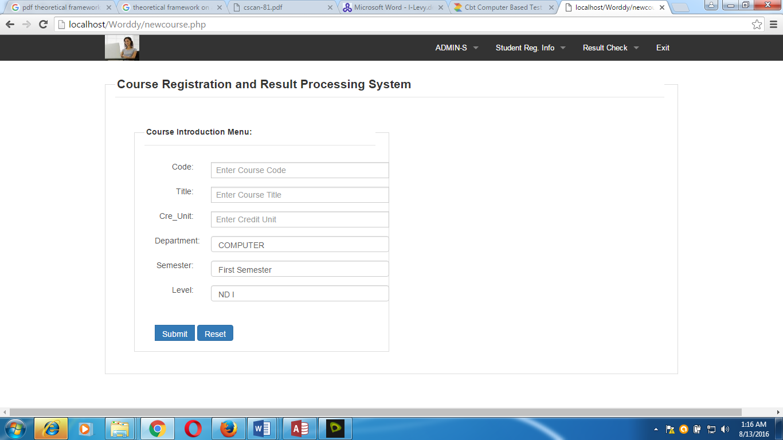

Department Introduction Menu

Figure 4.2: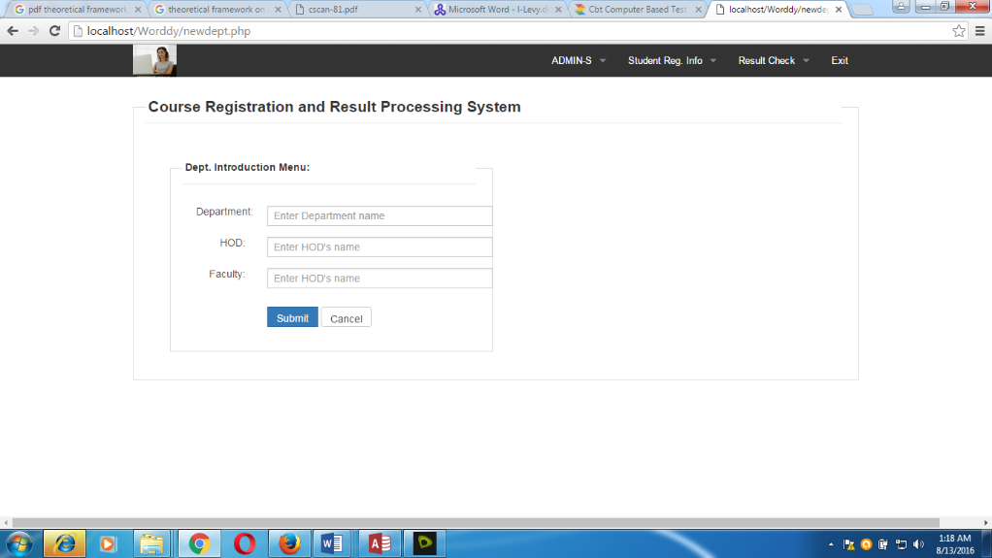

Figure 4.3: Snapshot for department introduction menu

Student Details

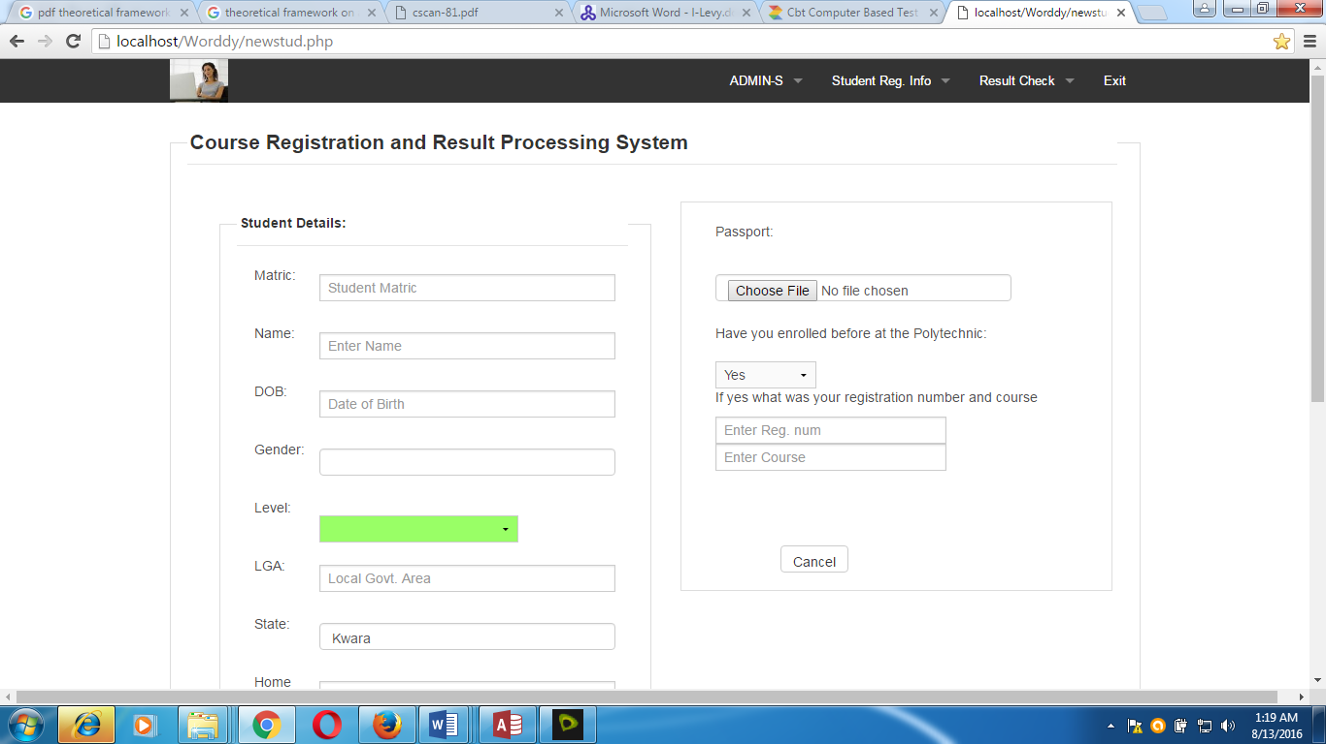

Score sheet menu

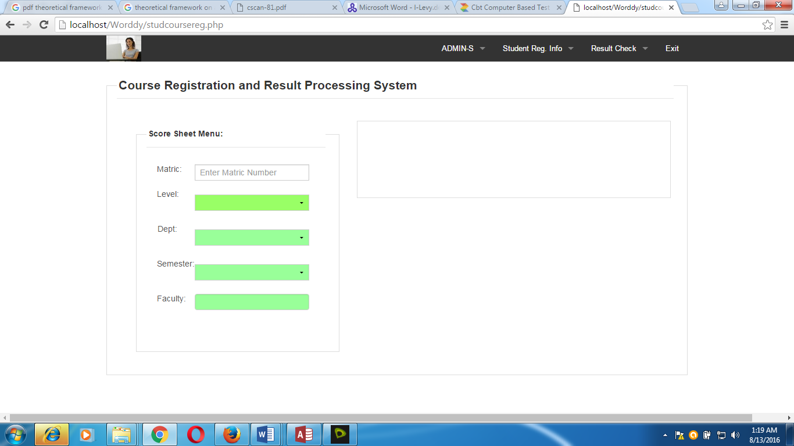 Figure 4.5: Snapshot for student course registration menu

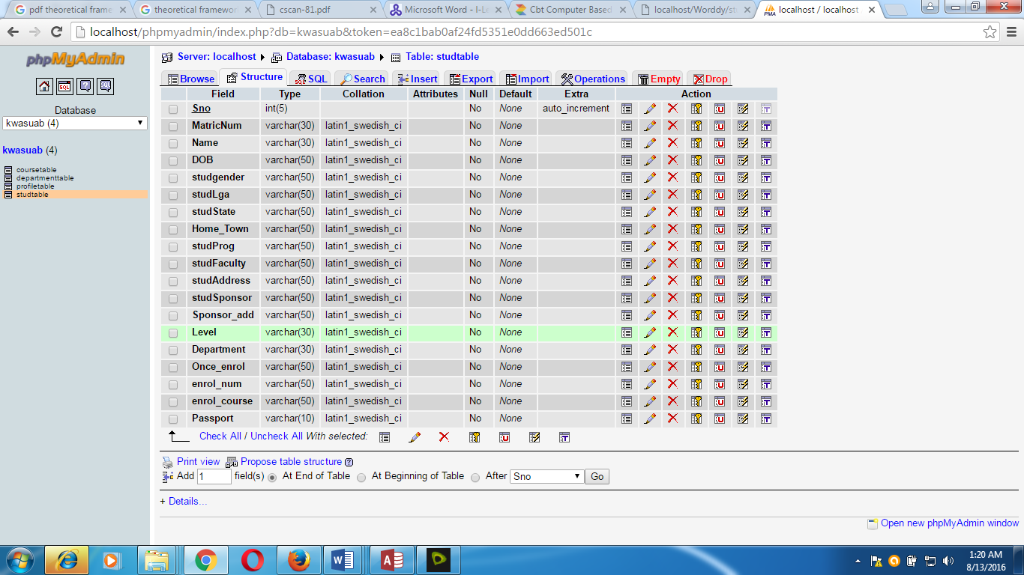

Figure 4.6: Question table

4.5 Program Description

Every stage of the system modification should meet the requirement that arise. The areas to be affected are the software aspect to cover new changes in software versions. Hardware like the hard disk capacity needs to be modified as the system continues, large hard disk space will be required for storing information.

In carrying out the maintenance of the system the procedure and function that has take place before installation must be accomplished according to procedure for making changes to the system the staff handling the new system should cultivate the attitude of maintenance for the hardware and software that makes up the system. At times staff needs to be retained in the area where major changes are made either to the system (PC) or the software.

4.6 Program Description

Every stage of the system modification should meet the requirement that arise. The areas to be affected are the software aspect to cover new changes in software versions. Hardware like the hard disk capacity needs to be modified as the system continues, large hard disk space will be required for storing information.

In carrying out the maintenance of the system the procedure and function that has take place before installation must be accomplished according to procedure for making changes to the system the staff handling the new system should cultivate the attitude of maintenance for the hardware and software that makes up the system. At times staff needs to be retained in the area where major changes are made either to the system (PC) or the software.

System Flowchart

MAIN MENU

ADMIN

Registration

Result Check

Exit

Course Introduction

Dept Introduction

Score Entry

Profile Registration

Course Registration

Course Introduction Flowchart

Enter course Details

Is Correct

Save to Database

Any more?

Close Database

Open Database

No

Yes

Yes

No

Admin Login Flowchart

Enter Logins

Correct?

Course

Dept

Score

Dept Introduction Flowchart

Enter Dept Details

Is Correct

Save to Database

Any more?

Close Database

Open Database

No

Yes

Yes

No

Profile Registration Flowchart

Enter profile detail

Is Correct

Save to Database

Any more?

Close Database

Open Database

No

Yes

Yes

No

Course Registration Flowchart

Enter Course Details

Is Correct

Save to Database

Any more?

Close Database

Open Database

Yes

No

Yes

Result View flowchart

No

Open Database

Enter Student number

Valid?

Close Database

Display Info.

PROCESS RESULT

Yes

No

4.6.1 Operating The System

To operate the system, the engineer is expected to give the tutorial to the user of the application in other to be familiar with the system develop. The modules have to be iron out one after the other to the users. Below are the following steps to operate the system;

Step 1: Insert CD into the CD ROM

Step 2: Click on Course RegresultPro

Step 3: The index page is display

Then navigate through the menu, for more information about the modules read again the procedures in this project work.

4.6.2 Maintenance Of The System

Maintenance this program can be done in HTMLenvironment. Any future modification can be done by re-compiling the source program in development environment making necessary changes versions of the existing version of the mini word processing applications.

**CHAPTER FIVE**

**Summary , CONCLUSION AND RECOMMENDATIONS**

**5.1 Summary**

The new course registration and result processing system is enhanced automated software that is built to eradicate the major problem inherent in the current system. The development of this system arose because of the growing rate at which students overstay in the school and the semi manual/digital method of result computation. A study investigated the cause of these problems and conclusion was drawn that it is caused by improper course registration and the manual method of result computation. Therefore the new system targets to arrest this situation by building features in the software that could not only produce a better system but mandate students to register any of their failed outstanding course before registering for the new courses in the current session and rewriting the exam on time. Secondly, study into the result processing system exposed the laborious nature of the system; it is time consuming and less effective. The new system is developed with the capability to extract students result from an excel result template and calculate the semester GPA for the student. This will not only enable the students to access themselves and improve their performance but will also help the exam officer to articulate and compile students result at final year.

**5.2 Conclusion**

In conclusion, this project presents software application that is capable of storing and process In students’ results with high speed and accuracy and presenting the output

in a certain required forms .It’ qualities include enabling or free registration, reduction in the cost and time spent in computing GPAs/ CGP As ,faster generation first semester transcript per student t and enabling the exam officer to view very session result of a whole class in a single sheet called the broadsheet, The Application is asytouse, reasonably secure and enforces data integrity resulting from the use of relational database management system.

**5.3 Recommendation**

The findings of this study exposed some salient is uses in the student ’course registration process that would require further automation. It is hoped that these issues will advance and promote further researches in schools and colleges. There commendations derived from this study are:

* Student’ awareness of their past academic performance increases their performance in subsequent semesters in school. It is recommended that student s result should be made available on time so that he/she can access himself before registering for new courses.
* Methodologies deployed in the system can be harnessed to allow the excel software to interface with the MYSQ L server in other to generate and present the broad sheet report from it. This is the only way that the broad sheet can be shown on a single sheet.
* The system can be reprogrammed to allow semester transcript result to be duly endorsed by any staff in charge online before the student can print a copy of the result.
* A component should be built into the excel result template so that the HOD can end or se there suit on the spread sheet file and then submit it to the administrator himself. This is to increase their liability of the data in the result template .Onset he HOD handle s and end or see the result, change can not be made to the result.

REFERENCES

(Ultra Scientist of Physical Sciences) Volume20,Number3(M),(2008)Page2

[1] MosesE.Ekpenyong.‘AReal-TimeIKBS for Students Results Computation’, International Journal of Physical Sciences

[10] Ukem E.O and Onoyom-Ita E.O ‘A Software Application for the Processing Of Students Results’, Global Journal of Pure and Applied SciencesVolume17No.4. (2011)Page1

[11] Ekpo Dan. ‘Registration and result processing system in Covenant University’ (2002) page9-12

[12] OderaTom Akal and Oloko MargaretA .‘Effect of Online Registration on Exam Performance in Kenya Certificate of Secondary Education Enrolment.’ American International Journal of Contemporary Research.Vol.3No.7(2013),page118

[2] Akinmosin James. Automated Students Result Management System Using Oracle’s Database, Form and Reports. Journal of Information Engineering and Applications.Vol.4, No. 11,(2014)Page1

[3] Ukem EyoO. And Ofoegbu Francis. ‘A Software Application for University Students Results Processing’ Journal of Theoretical and Applied InformationTechnology.Vol.35No.1,(2012)Page1,34-39

[4] Ezenma A. Añulika .Design and Implementation of Result t Processing System for Public Secondary Schools in Nigeria .Department of information Technology, National open university of Nigeria Lafia, Nasara wastate. Vol3,Issue 01.January2014.Page123

[5] Anigbogu, S.O .Computer Application and Operation First Edition .Optimum Press, Awka . (2000). Page18.

[6] Emmanuel Band Choji D.N. ‘A Software Application for Colleges of Education Students Results Processing’.Journal of Information Engineering and Applications.Vol.2,No.11, (2012)Page12-18

[7] Mar candy. Design and Implementation of Course Registration and Result Processing System. Caritas University, Amorji Nike Enugu. (2012) . Page13, 50-60

[8] Cardiff University. ‘Examination Result Processing Manual’. External ExaminerHandbook,http://www.cardiff.ac.uk/regis/ifs/exex/index.html.(2012).Page16-25

[9] MySQL Expert Guide:Available online:http://dev.mysql.com/doc/refman/5.6/en/tutorial.html.

Appendix B

Below are screenshot s of the system interfaces ,the logins, input and output for s of the application.

Figure4.2 shows the homepage with menu forth users’ login.

Figure4.3 shows the Admin login page where hence I the r add course, add staff, upload results, view broad sheet and prints report set.

Figure4.4 shows the form the Add-Course Form.

Figure4.5 shows the result uploaded interface. Here the Admin can select the necessary details of a course and then upload data from an excel file.

Figure4.6 shows the form for student course registration. Students select the session, the semester and the level. Click on the select course combo. It then lists all courses offered in that semester forth student’s registration.